Q1.
Answer is B.

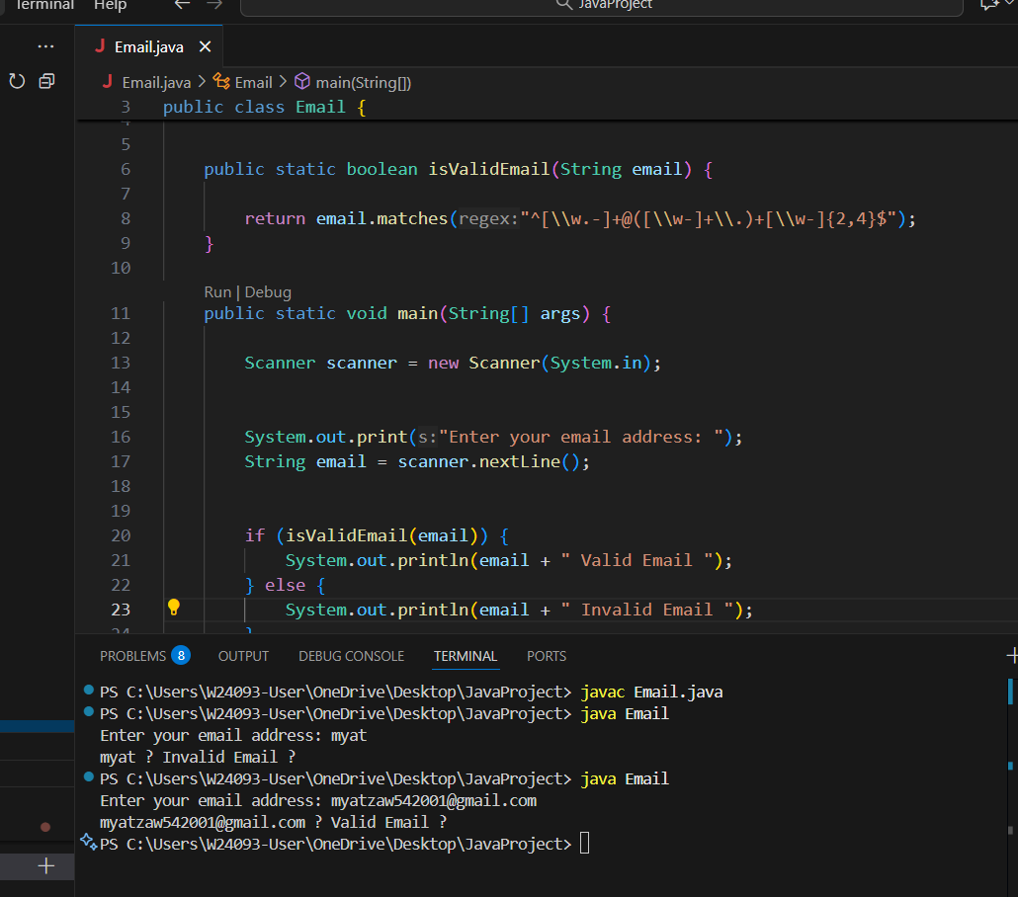

A: only checks for @ but doesn’t verify anything else.

B: Correct answer.

C: it only checks length, not format.

D: not all emails end with .com (some end with .org, .net, .edu, .gov, etc.).

Q2.
Answer is A.

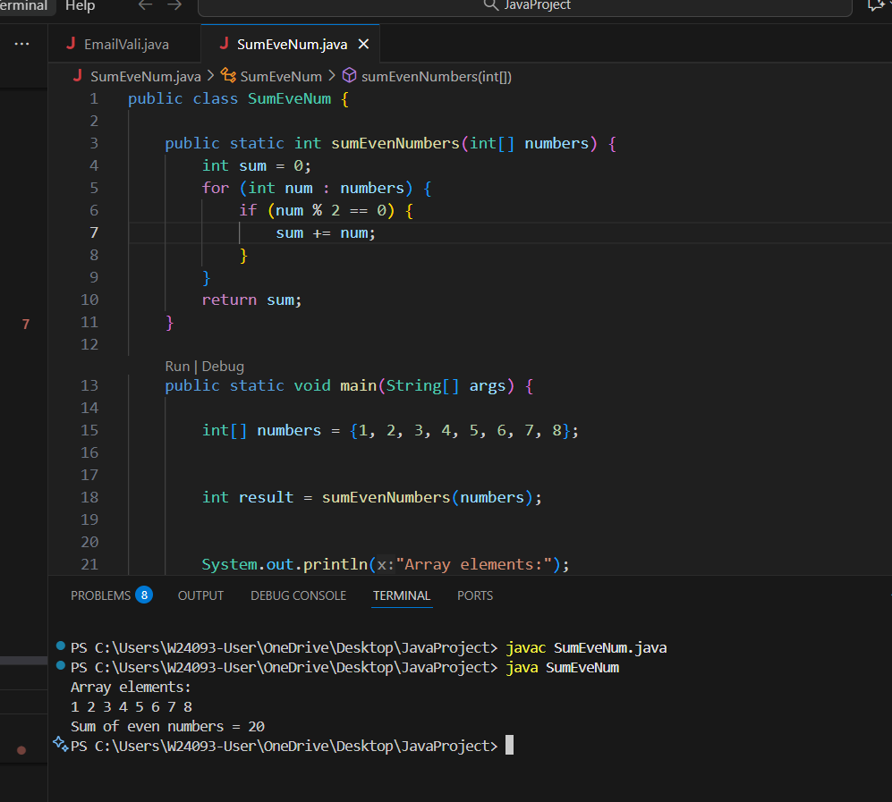

A: Return the sum of all even numbers in the array

B: this adds every 2nd element, not even numbers.

C: this checks for odd numbers, not even numbers.

D: this sums all numbers in the array without checking for even.

Q3.
Answer is B.

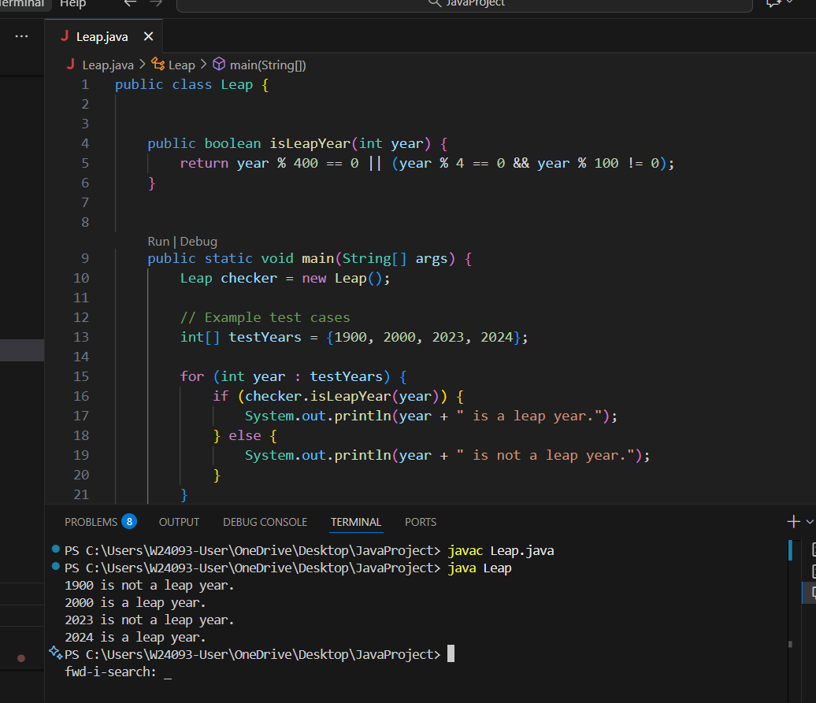

A: This checks only divisibility by 4.Fails for 1900 (divisible by 4, but not a leap year).

B: Correct Answer.

C: completely wrong.

D: This makes only century years that are divisible by 4 leap years.

Q4.
Answer is B.

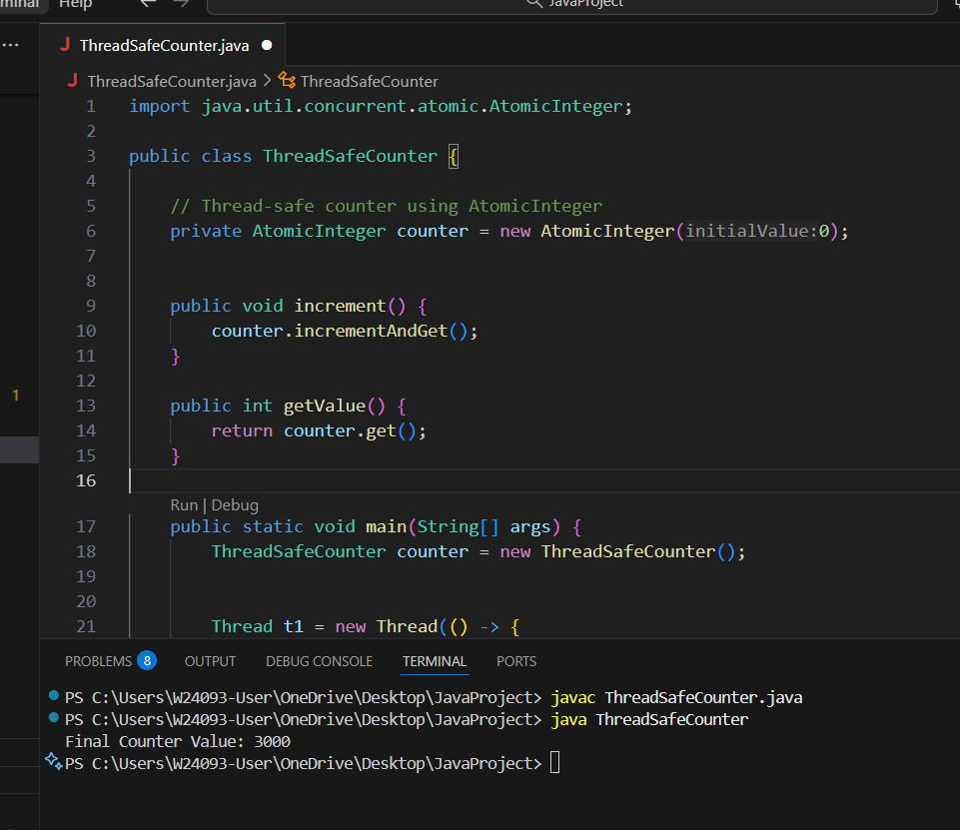

A: Counter may have incorrect values under concurrent access.

B: Best choice for high-performance multi-threaded applications.

C: simpler but less efficient than AtomicInteger.

D: Same problem as Option A (race condition).

Q5.
Answer is B.

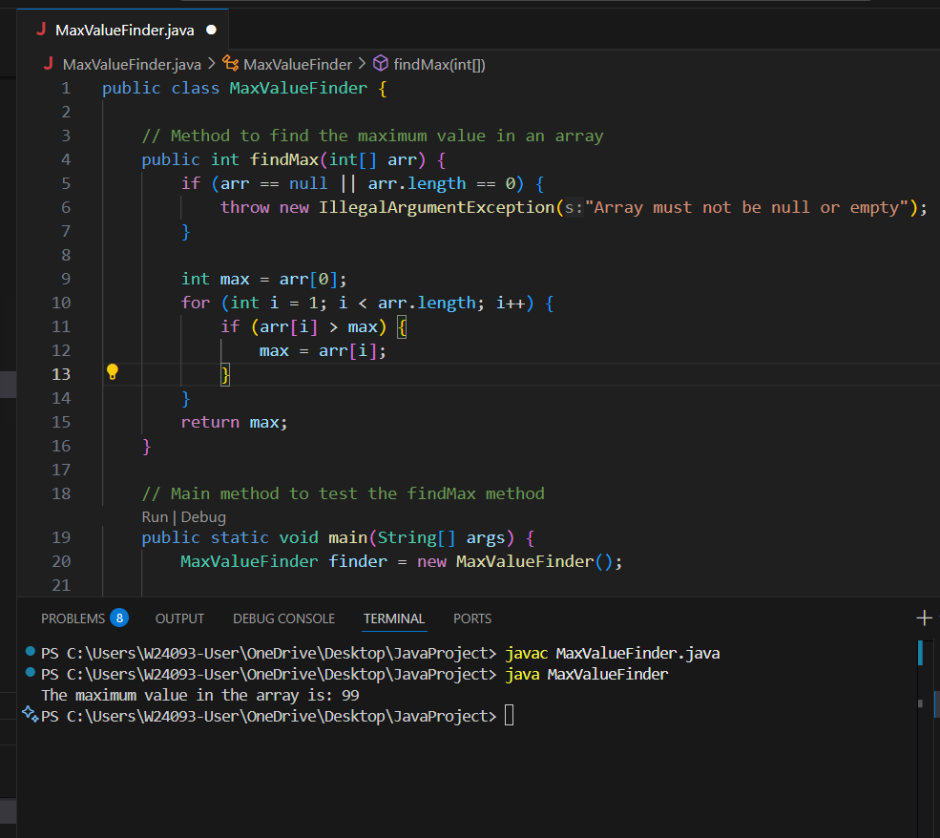

A: readable, and correct, but slightly more overhead than a simple loop.

B: Correct and most efficient.

C: Correct but inefficient.

D: Works only for Integer[], not int[].

Q6.
Answer is D.

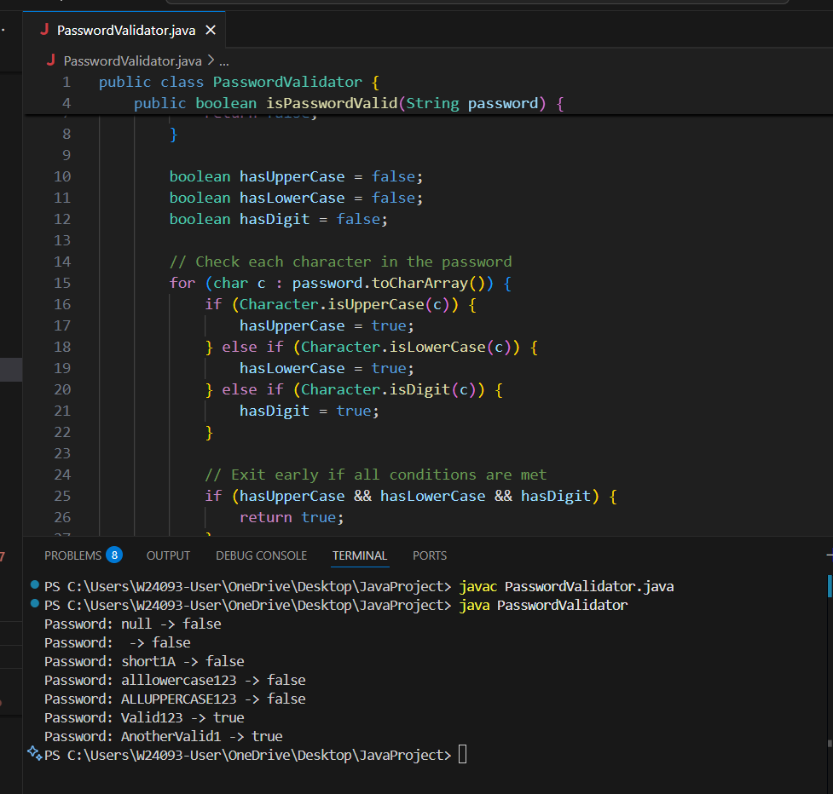

A: Missing special characters is a policy issue, not a vulnerability in this method’s execution.

B: the loop exits immediately once all conditions are met.

C: This is technically true,not considered a vulnerability.

D: The main vulnerability in this legacy code is:It does not check for null input, which can cause the application to crash.

Q7.
Answer is C.

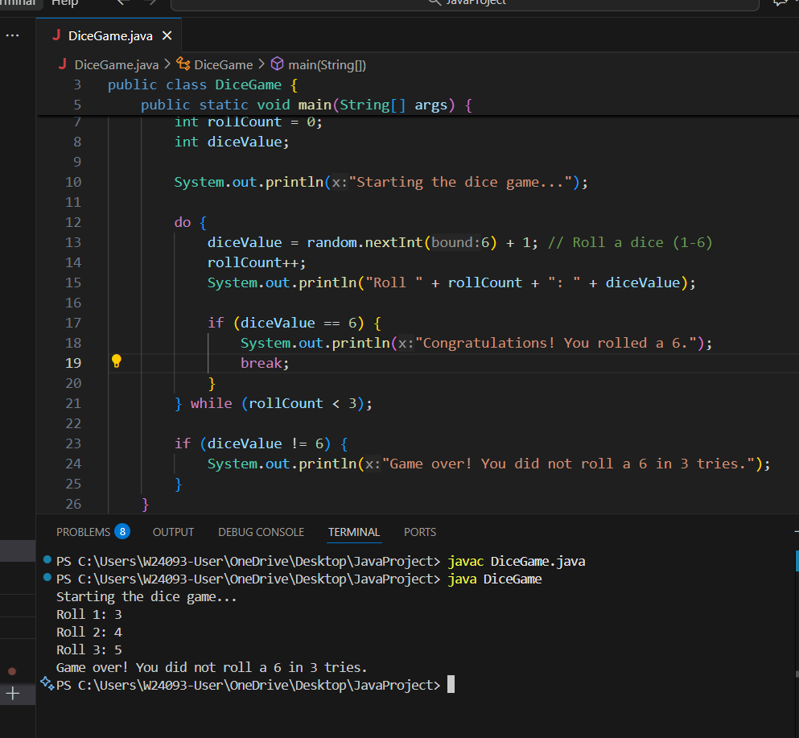

A: Not ideal.

B: Not ideal.

C: Best choice.

D: Not suitable.

Q8.
Answer is C.

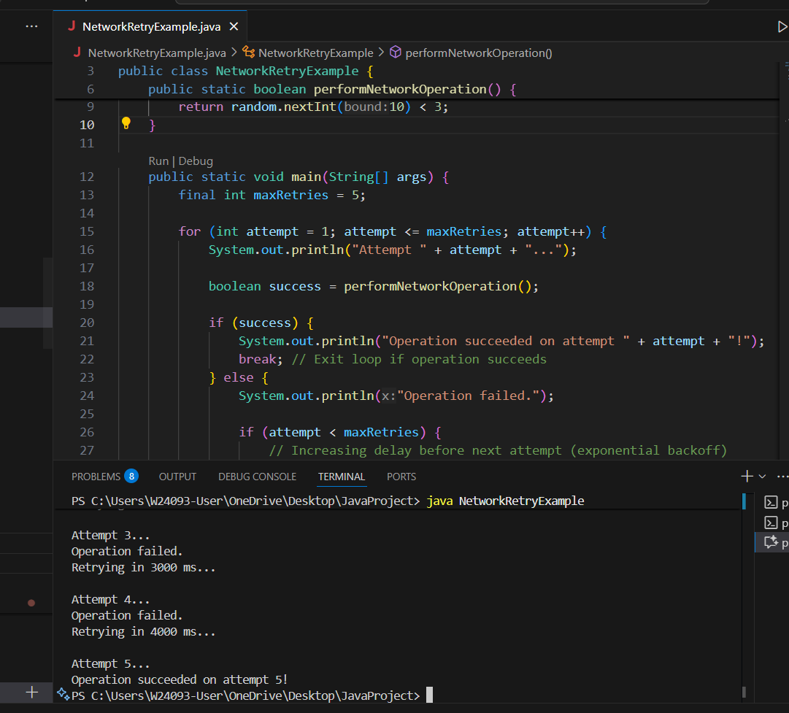

A: need manual increment of retryCount and care to avoid infinite loops.

B: Works, ensures at least one attempt, less clean for fixed retries

C: Expresses fixed retries clearly, integrates easily with delay logic

D: Requires a list of attempts, unnecessary

